**DAILY ONLINE ACTIVITIES SUMMARY**

|  |  |  |  |  |  |  |  |
| --- | --- | --- | --- | --- | --- | --- | --- |
| **Date:** | 23-06-2020 | | | | **Name:** | Gudugunti Anirudh | |
| **Sem & Sec** | IV - A | | | | **USN:** | 4AL18CS023 | |
| **Online Test Summary** | | | | | | | |
| **Subject** | | Iot(webinar) | | | | | |
| **Max. Marks** | | 15 | | **Score** | | 09 | |
| **Certification Course Summary** | | | | | | | |
| **Course** | C programming | | | | | | |
| **Certificate Provider** | | | Udemy | **Duration** | | | **11 hrs** |
| **Coding Challenges** | | | | | | | |
| **Problem Statement:**  1: program to find modular exponentiation. | | | | | | | |
| **Status:** Completed | | | | | | | |
| **Uploaded the report in Github** | | | | yes | | | |
| **If yes Repository name** | | | | https://github.com/alvas-education-foundation/anirudh_gudugunti/tree/master/daily_progress | | | |
| **Uploaded the report in slack** | | | | yes | | | |

**Online Test Details:** The test for today was from Iot. The test was of objective type questions and there were 15 questions and the duration was 20 minutes. The questions were optimal and easy. The score that I got was 09/15.

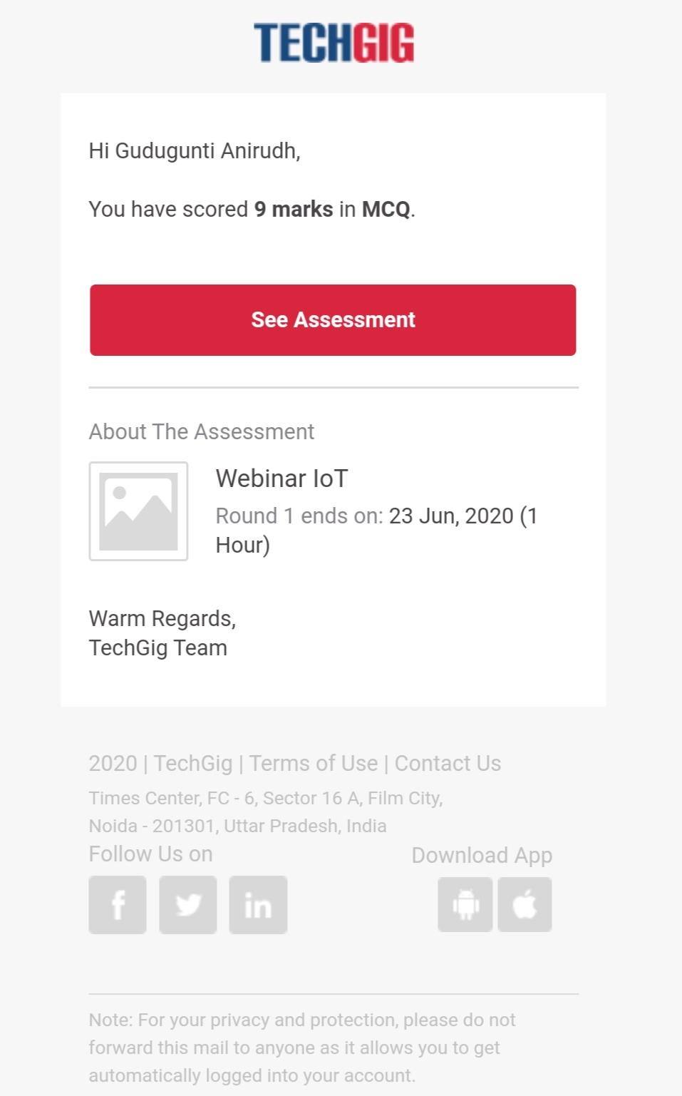

Snapshot of certification course:

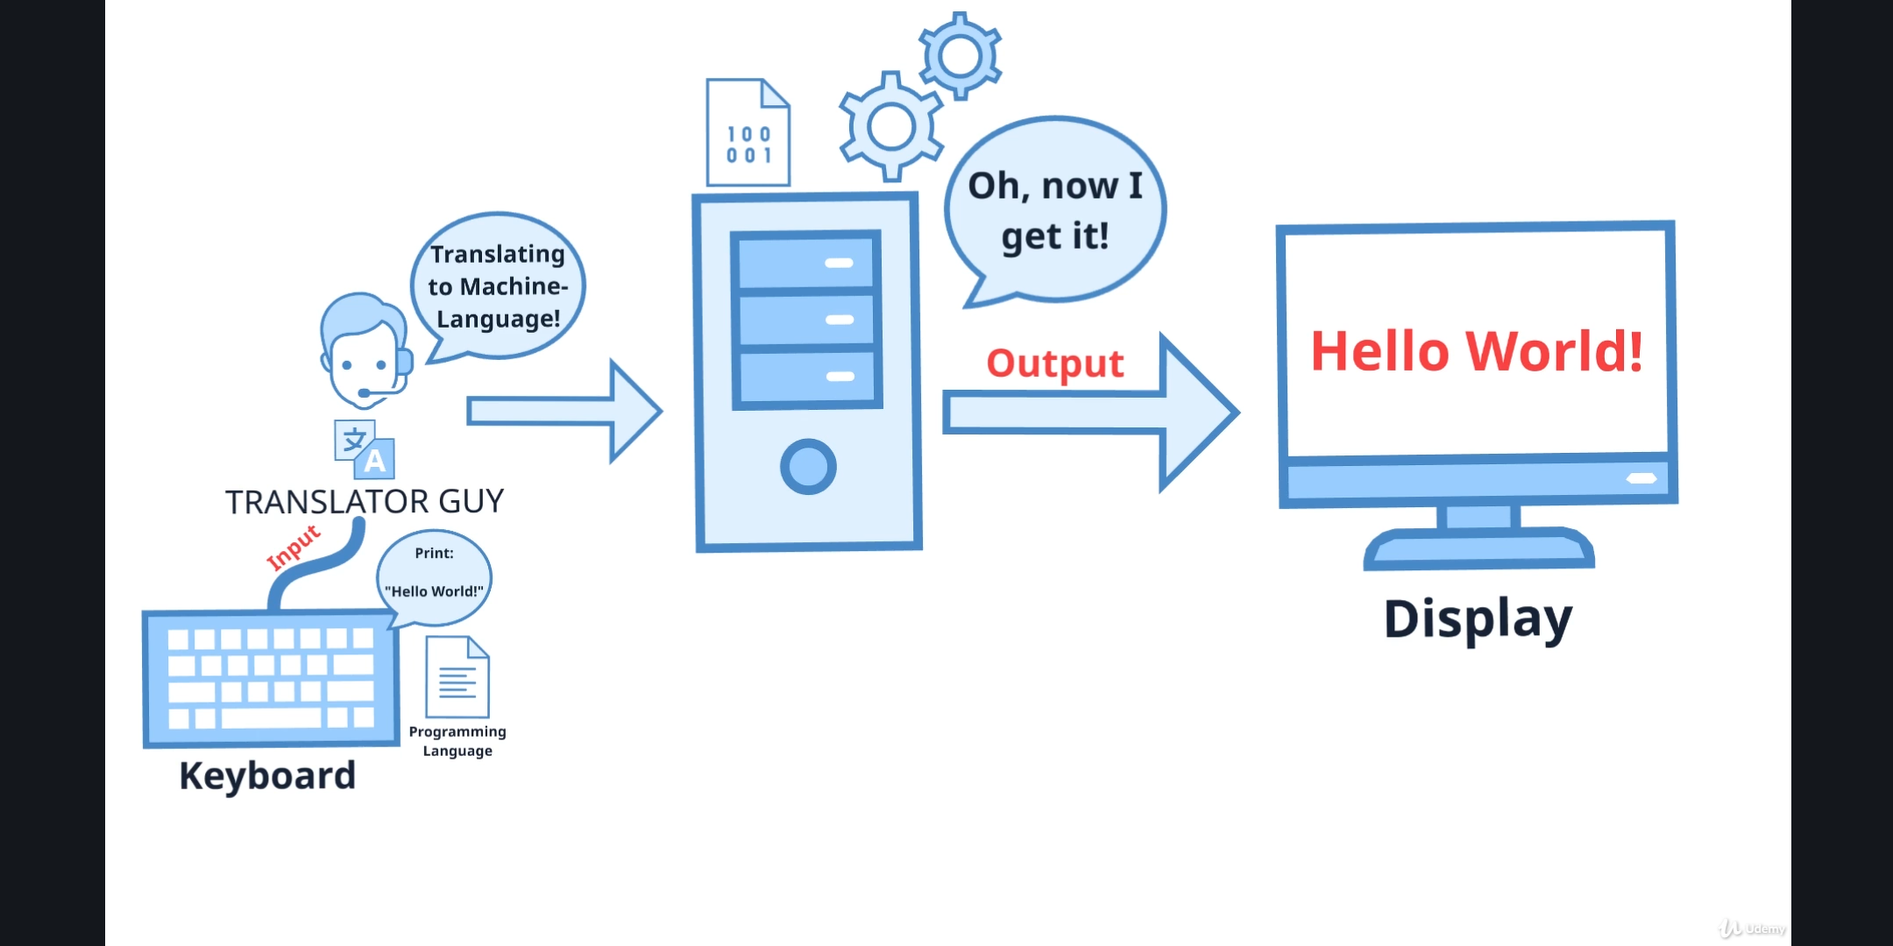

1. Importance of machine language.

2. How systems can understand the user input.

3. Detailed explanation on how systems can understand the user language.

**Online coding:**

Problem 1: (using JAVA) program to find modular exponentiation.

